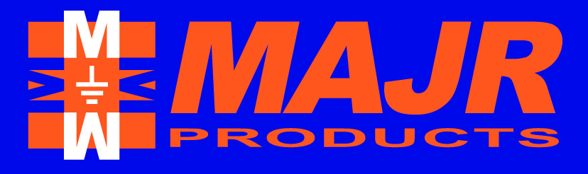
EMI / RFI Shielding Products
ISO 9001:2000 REGISTERED
“MAJR Difference MAJR Satisfaction”
“MAJR Difference MAJR Satisfaction”
PRODUCT
DATA SHEET
DS-7.2.1-SAL 2-29-12

Conductive Fluorosilicone Elastomer (5000 Series)
Product Summary

This conductive fluorosilicone elastomer material is a unique composite of high quality fluorosilicone and conductive Silver Nickel (Ag/Ni) microscopic particles.

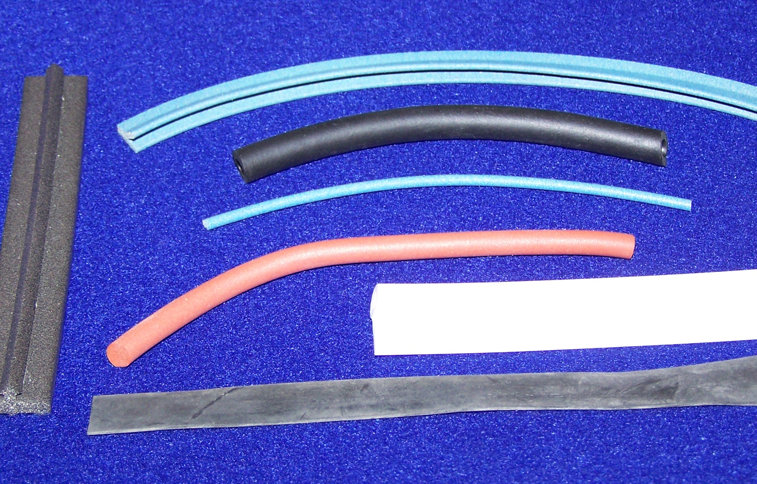
Product Application

This conductive elastomer is a unique composite of high quality fluorosilicone and conductive microscopic particles, manufactured to strict formulations, yielding a gasketing material that meets military MIL-DTL-83528 (Type L) and commercial electronic requirements. The fluorosilicone material is a synthetic rubber useful in applications involving petroleum oils, fuels, and silicone oils, with the same operating temperature as silicone.

The surface that this material is to be applied

to must be conductive, meaning no non-conductive paint, oils, or coatings. If a non-conductive surface is present on the mating or mounting surface the conductive elastomer, shielding effectiveness will be greatly degraded.

Contact MAJR Products Corporation for product configurations and part numbers.

Product Technical Data

Electrical Specifications | Tolerance | Test Method | Silver Aluminum  fluorosilicone Elastomer  (Ohm-cm)
Volume Resistivity | Maximum | MIL-DTL-83528  (PARA 4.6.11) | 0.005
Shielding Effectiveness (Frequencies) | Minimum | MIL-DTL-83528  (PARA 4.5.12) | Silver Aluminum Elastomer  (Attenuation - dB)
20 MHz (E-Field) | Minimum | (PARA 4.5.12) | 100
500 MHz (E-Field) | Minimum | (PARA 4.5.12) | 100
2 GHz (Plane Wave) | Minimum | (PARA 4.5.12) | 100
10 GHz (Plane Wave) | Minimum | (PARA 4.5.12) | 100

- 2 -

Conductive Fluorosilicone Elastomer (5000 Series) (Cont.)

Properties (General Specifications for Silver Aluminum Fluorosilicone Elastomer)
Hardness  (Shore A) | Tensile  (psi) | Elongation  (min. – max.) | Tear  (lb./in) | Operating Temperature Deg. C  (min. to max.) | Specific Gravity  (g/cc)
75 | 200 | 100 - 300 | 30 | -55 to +125 | 4.0

HUBZONE Certified and Veteran Owned Manufacturer

MAJR Products Corporation
17540 State Highway 198
Saegertown, PA 16433
PH: (814) 763-3211 FX: (814) 763-2952
www.majr.com email; sales@majr.com

